
Competition Handbook 2026-2027

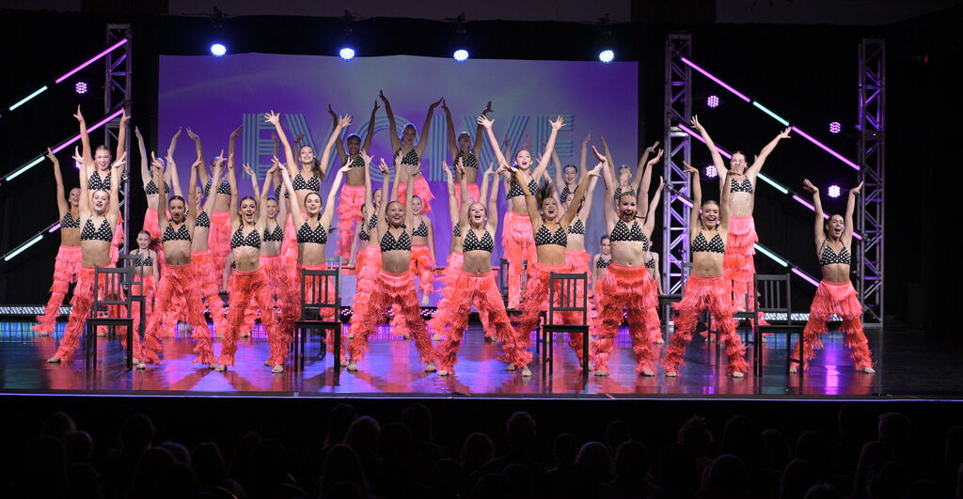

Calgary, AB T2C 1J5 4615 - 112th Ave SE
Bay 325
403.256.2100
www.boundlessdancestudio.com
boundlessdancestudioinc@gmail.com

General Competition Expectations
It is expected that a dancer wanting to participate in the competitive program be committed and understand what is expected of them. A lot of extra time, practice and costs are required and must be fully understood before committing to the competitive program. Boundless Dance Studio strongly encourages students to work together as a team; therefore every student will be expected to adhere to the following:
- It is understood that in order to compete you must attend ballet class, stretch class, and the elective classes you have chosen on a REGULAR & CONSISTANT BASIS. If you choose not to attend your classes regularly, you will be notified and asked not to participate in the appropriate competitive numbers. Please be considerate and respectful by notifying the studio if you will be absent. All competitive dancers are expected to be in regular classes before and during our competitive season – it is no different than preparing for any other team sports. Please note that regular attendance checks will be made. All technique classes the week leading up to competitions are mandatory.

- Students and Parents are required to:
  - *Fill out & Return Competition Wish List by May 19th, 2026, with $30 Registration Fee & $375.00 Intensive Fee. These fees are non-refundable. Please note late entries may not be given priority.
  - *Fill out, sign and return the Approval Form with Choreography Fees by September 23rd, 2026. This also includes your dancer fee and rehearsal fees.
  - Pay $75/dancer fee to cover costs for all teachers and staff present at competitions.
  - Pay $25.00/group dress rehearsal fee.
  - *Attend Competition Meeting (Saturday, September 19th at 11:00AM BDS)
  - *Attend the MANDATORY studio Summer Intensive Workshop Audition August 18th-20th- Tuition Due May 19th, 2026. This will be a three-day workshop.
  - *Attend mandatory dress rehearsals
  - *Attend all four (4) studio competitions. This includes all dances you are chosen for and any applicable dance-offs.
  - Possible solo, duo, trio dress rehearsal. To be discussed at meeting.
- Students are required to be in attendance once choreography of group numbers has commenced, through to the conclusion of the competitive season. It is mandatory for all students to be in attendance for the last 2 scheduled competition rehearsals and the week before any studio competition (with the exception of the Studio’s closure for Spring Break). *Dancers are only allowed 2 absences from scheduled rehearsals* Please make sure your calendars are up to date. We strongly encourage everyone to work as a team and be considerate to fellow classmates, instructors and staff, as absences can affect your own performance as well as those of other dancers. Please note, action will be taken against dancers not following these rules. Training in regular classes will also be monitored for competitive placement. **NEW THIS SEASON** Mandatory weekends will be scheduled. Weekends will be noted when your schedule is sent out.

- It is the dancer's responsibility to remember choreography to learn and practice any choreography missed due to absences before their next practice. If choreography is forgotten, it may result in a student being pulled from the group number or billed an additional fee of $50.00/hr for loss of time.

______________________________________________________________

Boundless Dance Studio


NOTES

Mandatory Competition Information Meeting

WHERE: Boundless Dance Studio (Bring a chair)

WHEN: Saturday, September 19th, 2026
TIME: 11:00 AM

- To ensure no time is being lost, we ask that all dancers ensure muscles are stretched and warmed up properly for the appropriate competitive number before entering all choreography classes and extra competition lessons. *Arrival 15 minutes prior is suggested. *
- Please Note: Dancers must be involved in the group competition numbers in a specific discipline, to be considered for a solo, duo, trio or small group of that said discipline. (ie: ballet group, then ballet solo/duo etc.
- Please note recital is not optional as a competitive dancer.

Please keep in mind that participation in the Competitive Programs is a PRIVILEGE
and needs to be worked for and earned…...not just expected.

Competition Costs

WHO: Parents of dancers who are wanting to participate in competition (no dancers please)
**absolutely NO exceptions**

DETAILS: We will be discussing competition expectations, guidelines, etiquette, dates, etc.

Please bring this notebook with you to this meeting

Choreography Fees*:
Solos (3 hours) $395.00
Duets & Trios (3 hours) $220.00
Groups (4-7) (max. 9 hours) $195.00

*All fees are per person and include the use of the facilities, choreography, cleaning of the routine and music preparation.

Choreography fees will be invoiced upon completion of the Competition Approval Form and can be made payable to Boundless Dance Studio. All Choreography Fees are due by SEPTEMBER 23rd, 2026 and are NON-REFUNDABLE.

**No choreography will be started until fees are paid in full**
- Competition Entry Fees:
In order to enter any competition, you must pay an entry fee. As every competition charges different entry fees, we have averaged the costs of the four (4) studio competitions we participated in last year (GST is included in all fees):

Solos $445.00/solo for all four competitions Duets/Trios $295.00/dancer for all four competitions Groups $250.00/dancer for all four competitions
Media Fee $50.00/dancer approx. for certain comps

You can expect to pay these amounts for this season pending entry fees stay relatively the same - but entry fees are subject to change

An invoice will be sent out for each individual student. To be entered into a competition by Boundless Dance Studio, you must submit your cheque as requested on your invoice emailed to you. Payments are to be made payable to Boundless Dance Studio and must be returned by the deadline provided.

(see next page)

Prop Fees:
A fee will be charged for props used for competition numbers. The total cost of the props used, would be divided between the participants in the number.

Costume Fees:
The amount set on a solo, duet or trio costume depends on the type of design and cost of the material you choose.

When picking your costume designs and material, you must ensure you have approved everything with the instructor who has choreographed the routine before incurring any costs.

You may choose to have your costumes custom made, ordered from one of the studio’s selected catalogue or purchase your own. If ordering from a catalogue,
PARENTS are responsible for writing style #, colour, and size chosen for dancer on the order form. (Take care when placing your order, as you are responsible for any errors you make.) Please include all accessories you wish to purchase with your costume (ie. hairpiece, gloves, hat, tutu, etc.) All alterations are at the dancers expense. Custom costumes need to be completed by February 15th, 2026.

The choreographer has final approval on all costume designs and will decide all group costumes.

You can expect to pay an average of $150 - $250 for a group costume.

Summer Intensive Workshop Audition Fees:
All competitive students MUST attend the studio for a THREE-DAY Summer Intensive Workshop Audition taking place Aug 18th -20th, 2026 $375.00/dancer plus a $30 registration fee. These are non-refundable.

Boundless Team Wear:
Show your BDS PRIDE!
All competitive students will be required to purchase an official competitive team jacket and wear it at all BDS competitive team events. Other clothing options will be available to purchase as well.

Outside Choreography:
Outside choreography is a decision made by Miss Jen, and dancers/families will be approached with that offer. Please note that the fee for outside choreography will most likely be more expensive than our regular rate. Cleaning of the routine will be offered at an additional fee, depending on studio and staff availability. Outside choreography requires an extra level of commitment as the routine will be taught in a short time frame.

Boundless Dance Studio

General Information
Competitions:
The studio will participate in four (4) competitions this year. It is understood that once you have commitment to a solo, duet or group, you are agreeing to participate in all four studio competitions. Every competition number (solos, duets, groups, etc.) will be entered in all four studio events unless otherwise stated or approved by instructors and Miss Jen. If the studio makes it into provincials, dancers are expected to attend for their dances.

If you cannot commit to all four (4) competitions, please do not consider
yourself for the competitive program.
An additional competition may be offered at an additional fee.

Music:
Prior to the first rehearsal, students are required to supply 2 choices of music for their solos, duos & trios. During the first rehearsal, the choreographer and students will finalize the music choice. All music for groups is chosen only by the
choreographer. Every student participating in a group is strongly encouraged to practice their routines with music. Please ensure you have a copy of all your group music.

Scheduling Private Lessons:
Competition private lessons will run during the week if there is time available, other-
wise most lessons will run on the weekend. All schedules are set by the teachers – we do our best to accommodate but cannot work around individual schedules.

**Schedules will be emailed**

Schedules:
October—December will be given out the last week of September. January—March will be given out prior to Christmas Break.

Cancellation Policy:
If for any reason you are unable to attend your private lesson, we ask that you find someone to swap times with or take your place. If you cannot find anyone to swap, there is a fee of $50 and must be paid to the office prior to the next scheduled rehearsal. We ask that you respect the instructor's availability, as there is limited amount of time and space to do competition choreography. Commitment is required when agreeing to taking on extra competition work.

